Software Development Life Cycle (SDLC)
The Software Development Life Cycle (SDLC) is a structured process used by software development teams to design, develop, test, and deploy high-quality software. It breaks the entire development journey into clear, manageable phases. By following SDLC, organizations reduce project risk, improve efficiency, and ensure that the final product meets user expectations.
The SDLC model is widely used in IT, software engineering, and project management because it brings clarity, consistency, and predictability to complex software projects.

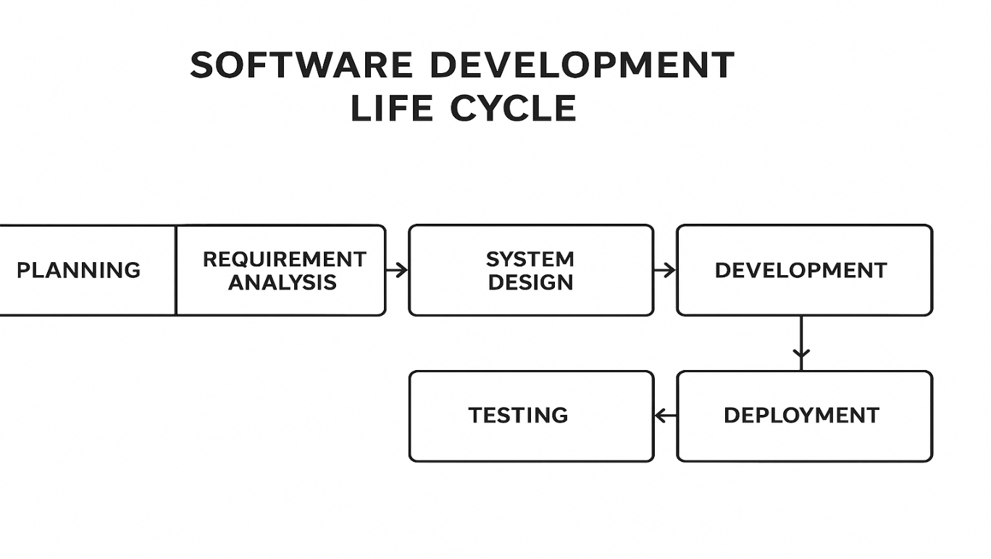

1. Planning Phase
The planning phase is the foundation of the entire SDLC. It sets the direction for the project.
Key activities:
- Define project scope and goals
- Identify stakeholders
- Estimate time, cost, and resources
- Conduct feasibility studies
- Identify risks and limitations
A well-structured planning phase helps the team understand the project’s objectives and constraints clearly.
Diagram – Planning, Analysis, Design Flow:
[ Planning ] ---> [ Requirement Analysis ] ---> [ System Design ]

2. Requirement Analysis Phase
In this phase, stakeholders such as clients, managers, analysts, and end-users define what the system must do.
Deliverables:
- Software Requirement Specification (SRS)
- Use cases
- User stories
- Functional & non-functional requirements
Clear requirements reduce project misunderstandings and rework later.

3. System Design Phase
The design phase outlines the system architecture and technical structure.
Activities include:
- High-Level Design (HLD)
- Low-Level Design (LLD)
- UI/UX design
- Database design
- Security and system flow design

4. Development Phase
This is the coding phase, where developers implement the system based on the design documents.
Activities:
- Writing clean, efficient code
- Following coding standards
- Code reviews and version control
- Integration of all modules
The development phase is often the longest in the SDLC.

5. Testing Phase
Testing ensures the software is free from defects and functions correctly.
Common types of testing:
- Unit Testing
- Integration Testing
- System Testing
- Performance Testing
- Security Testing
- User Acceptance Testing (UAT)
This phase helps identify bugs early before deployment.

6. Deployment Phase
After successful testing, the software is released for actual use.
Deployment may include:
- Server setup
- Installation of software
- Configuration and environment setup
- Monitoring system performance
Deployment can be done in stages (beta release) or all at once.
Simple Deployment Flow:
Development ---> Testing ---> Deployment ---> Maintenance

7. Maintenance Phase
Once deployed, the software enters the maintenance phase, where it is continuously supported and improved.
Types of maintenance:
- Corrective: Fixing bugs
- Adaptive: Updating due to environment changes
- Perfective: Adding new features
- Preventive: Improving long-term performance
This is the longest phase of the SDLC and ensures the system remains functional and reliable.

Why SDLC is a Cycle ?
The Software Development Life Cycle (SDLC) is described as a cycle because the process of developing software is continuous and repetitive, not a one-time activity. After a system is deployed, new needs, problems, and improvements always appear, which send the project back into earlier phases again.
Here are the reasons in detail:

1. Software Needs Continuous Updates
After deployment, users often request new features or changes.
These new requirements lead back to the Planning → Analysis → Design → Development phases again.
This repetition makes the process cyclical.

2. Bugs and Issues Must Be Fixed
Software is never perfect.
During Maintenance, bugs or performance issues are discovered.
To fix them, the team may need to revisit:
- Planning
- Design
- Development
- Testing
This loop keeps repeating.

3. Technology Keeps Changing
New technologies, security standards, and hardware appear frequently.
To keep software up to date, the cycle restarts and software is upgraded accordingly.

4. Business Requirements Evolve
Companies grow and change.
Their tools and applications must adapt.
Every new requirement sends the project back to the start of the cycle.

5. Ensures Continuous Improvement
The cyclical nature of SDLC ensures:
- Better quality
- Ongoing enhancement
- Higher customer satisfaction
- Long-term system reliability
In this way, SDLC becomes a loop of planning → building → improving.

6. Maintenance Leads Back to the Beginning
The final SDLC phase, Maintenance, often uncovers:
- New requirements
- New bugs
- Feature requests
This sends the project back into the cycle, making SDLC never-ending as long as the software is in use.

